**What is Swagger:-**

Open source tool to documenting API

**Why we need Swagger as developer:-**

Otherwise hmme contract doc bna k share krna hoga front end ko taki usko pta chale api, request, response. Aur agar api update ho gyi toh? Update .doc file also

So isse better use swagger tool

**How Swagger Works**

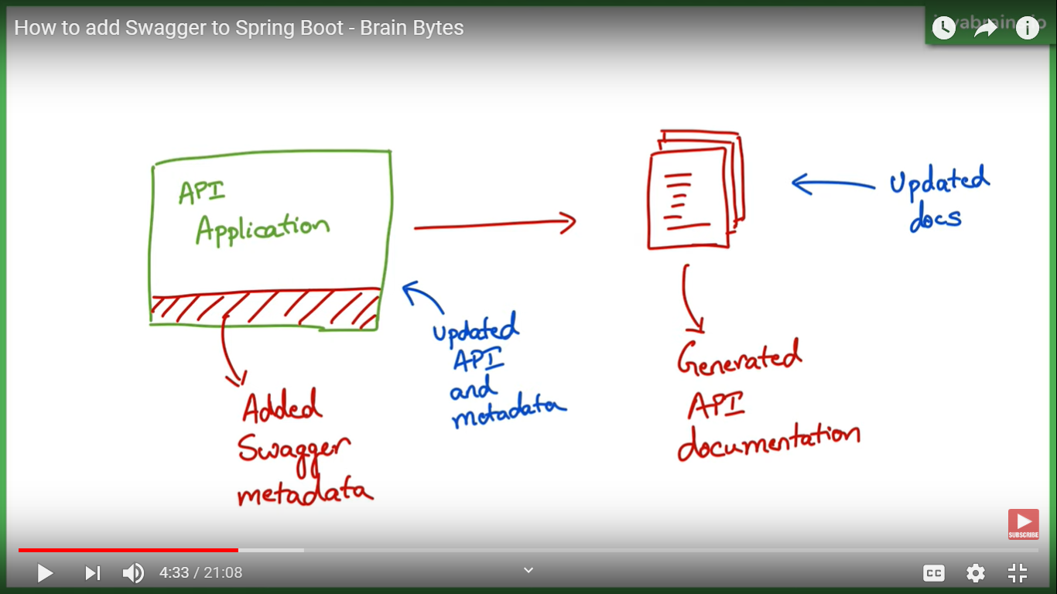

* Add some swagger meta data and swagger us data ko process krke json and html documentation taiyar kr deta h api ka.
* Agar api update ho toh bs update meta data, sb apnea aap update ho jayega on next build. No need of manual update .doc

**Adding Swagger To springBoot application**

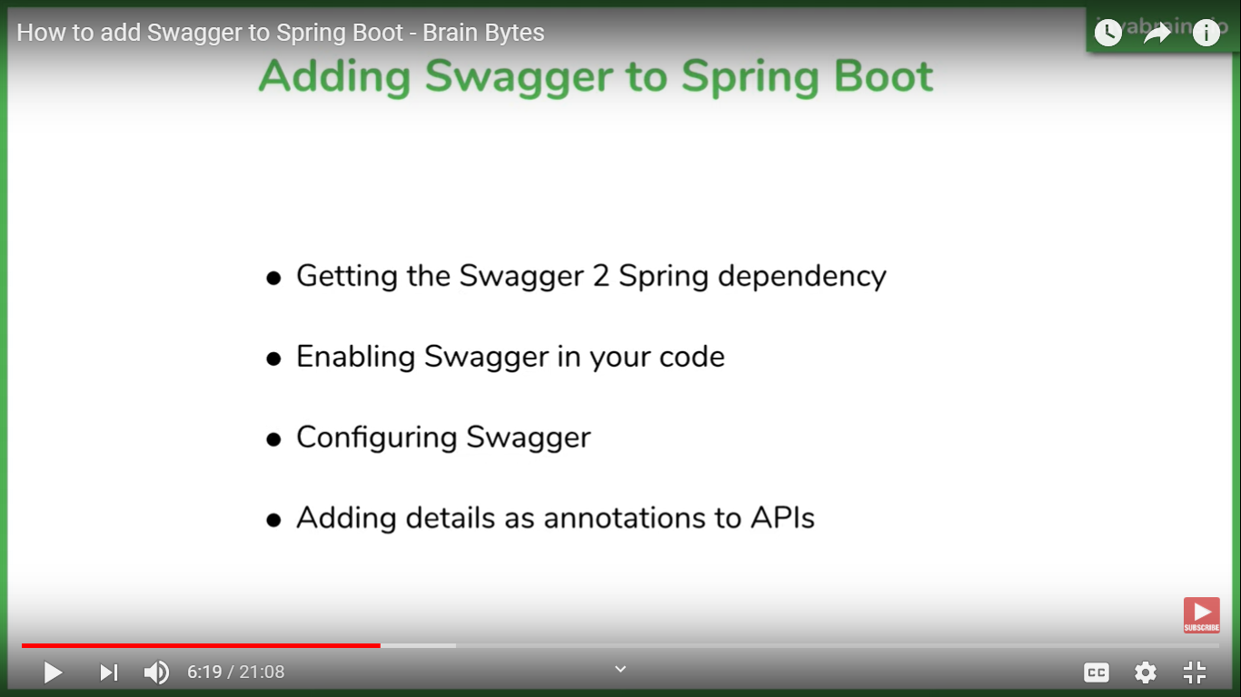

**Steps:-**

1. **Addind Swagger ki spring vali dependency:-**

So here We are using springfox swagger 2 dependeny

It generates Json documation

1. **Enabling Swagger 2:-**

Add annotation to main application as @EnableSwagger2

Now Restart Server, and see the Magic, u will find one more api working on postman, try to hit

**localhost://{portno}/v2/api-docs**

**here my project was running on 8085 port**

for UI html documentation add Springfox swagger UI dependency..

now at application ke root level pe swager Ui vali api add ho jayegi

**localhost:8085/swagger-ui.html**

1. **(Not needed this step just to extra) Customizing(configuring) ki kinka documention dikhana h swagger se and extra faltu cheezo ko hta na.**

Problem1:- out of box extra cheez jo spring mvc implement krti h vo bhi dikhata h swagger m

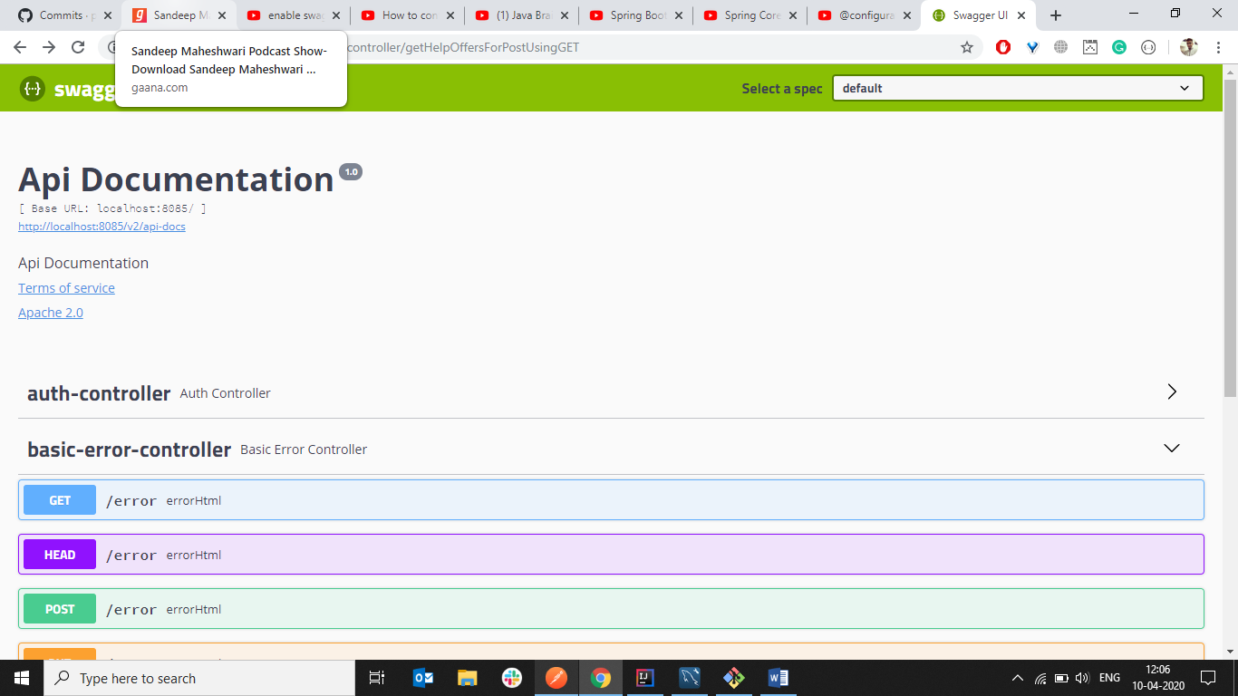

Problem 2:- documention ka name jo aata h usko apne hissab se customize krna apne project ka name dena.. advanced m api ka description, request ka , response ka many more par utna ni krte use bhot jyada annotations ho jayegene

Jab application run hoti h toh swagger ko docket ka object chaiye hota h bna hua jiske andar hum apne hisaab se add kr dete h data

/error ko hatana

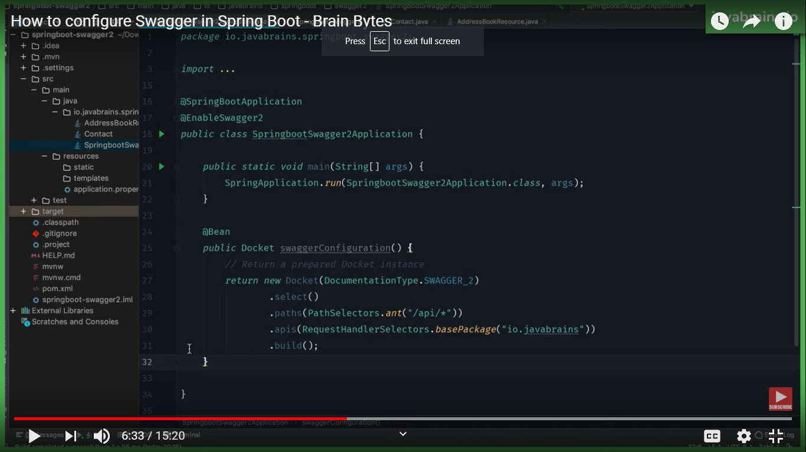

Adding meta data, docket k object pe add krna hota h

